Devika.B
Roll No:22

Experiment 12

Calculate Area and Perimeter Using
Interfaces
Aim:

Write a Java Program to create an interface having prototypes of functions ‘area()‘ and
‘perimeter()‘. Create two classes ‘Circle‘ and ‘Rectangle‘ which implement the above
interface. Develop a menu-driven program to find the area and perimeter of these shapes.

Source code:

import java.util.Scanner;

// Interface with method prototypes for area and perimeter
interface Shape {
double area();
double perimeter();
}

// Circle class implementing Shape interface
class Circle implements Shape {
double radius;

Circle(double radius) {
this.radius = radius;
}

@Override
public double area() {
return Math.PI * radius * radius;
}

@Override
public double perimeter() {
return 2 * Math.PI * radius;
}
}

// Rectangle class implementing Shape interface
class Rectangle implements Shape {
double length, width;

Rectangle(double length, double width) {
this.length = length;
this.width = width;
}

@Override
public double area() {
return length * width;
}

@Override
public double perimeter() {
return 2 * (length + width);
}
}

// Main class for menu-driven execution
public class AreaPerimeterCalculator {
public static void main(String[] args) {
Scanner scanner = new Scanner(System.in);

while (true) {
System.out.println("\nMenu:");
System.out.println("1. Circle - Area & Perimeter");
System.out.println("2. Rectangle - Area & Perimeter");
System.out.println("3. Exit");
System.out.print("Enter your choice: ");
int choice = scanner.nextInt();

switch (choice) {
case 1:
System.out.print("Enter radius of the circle: ");
double radius = scanner.nextDouble();
Circle circle = new Circle(radius);
System.out.println("Area of Circle: " + circle.area());
System.out.println("Perimeter of Circle: " + circle.perimeter());
break;
case 2:
System.out.print("Enter length of the rectangle: ");
double length = scanner.nextDouble();
System.out.print("Enter width of the rectangle: ");
double width = scanner.nextDouble();
Rectangle rectangle = new Rectangle(length, width);
System.out.println("Area of Rectangle: " + rectangle.area());
System.out.println("Perimeter of Rectangle: " + rectangle.perimeter());
break;
case 3:
System.out.println("Exiting program...");
scanner.close();
return;
default:
System.out.println("Invalid choice! Please try again.");
}
}
}
}
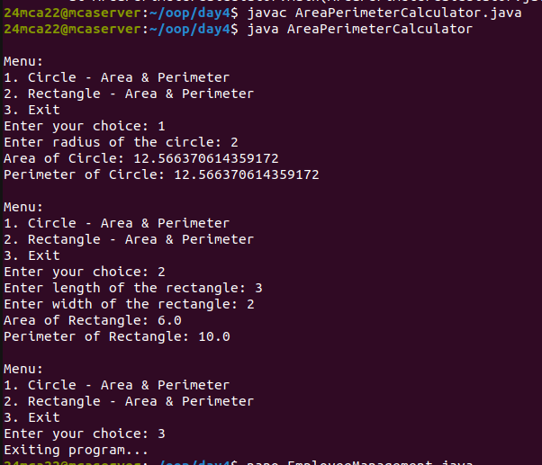

Experiment 13

Program to Manage Employee
Collection
Aim:

Create a Java program to manage a collection of employees in a company. Implement an
abstract class Employee with fields name (String) and salary (double), and an abstract
method calculateSalary(). Create two subclasses: Manager (with a bonus field) and
Developer (with an experience field), both overriding calculateSalary() to calculate
the total salary. Implement an interface Benefits with a method calculateBenefits(),
where Manager provides a fixed insurance benefit and Developer provides an allowance
based on experience. Use polymorphism to store Employee objects in a list and display
employee details and salary. Add method overloading in Manager for project assignment,
where one method takes just a project name and the other takes both the project name
and the number of team members.

Source code:

import java.util.ArrayList;
import java.util.List;
import java.util.Scanner;

// Abstract Class: Employee
abstract class Employee {
String name;
double salary;

Employee(String name, double salary) {
this.name = name;
this.salary = salary;
}

abstract double calculateSalary();

void display() {
System.out.println("Name: " + name);
System.out.println("Base Salary: $" + salary);
System.out.println("Total Salary: $" + calculateSalary());
}
}

// Interface: Benefits
interface Benefits {
double calculateBenefits();
}

// Manager Class (inherits Employee, implements Benefits)
class Manager extends Employee implements Benefits {
double bonus;

Manager(String name, double salary, double bonus) {
super(name, salary);
this.bonus = bonus;
}

@Override
double calculateSalary() {
return salary + bonus;
}

@Override
public double calculateBenefits() {
return 5000; // Fixed insurance benefit
}

// Method Overloading: Assign Project
void assignProject(String projectName) {
System.out.println(name + " assigned to project: " + projectName);
}

void assignProject(String projectName, int teamMembers) {
System.out.println(name + " assigned to project: " + projectName + " with " + teamMembers + " team members.");
}
}

// Developer Class (inherits Employee, implements Benefits)
class Developer extends Employee implements Benefits {
int experience;

Developer(String name, double salary, int experience) {
super(name, salary);
this.experience = experience;
}

@Override
double calculateSalary() {
return salary + (experience * 500);
}

@Override
public double calculateBenefits() {
return experience * 200; // Allowance based on experience
}
}

// Main Class
public class EmployeeManagement {
public static void main(String[] args) {
Scanner scanner = new Scanner(System.in);
List<Employee> employees = new ArrayList<>();

// Adding Employees
System.out.print("Enter number of employees: ");
int n = scanner.nextInt();
scanner.nextLine(); // Consume newline

for (int i = 0; i < n; i++) {
System.out.println("\nEnter details for Employee " + (i + 1));
System.out.print("Type (Manager/Developer): ");
String type = scanner.nextLine();

System.out.print("Name: ");
String name = scanner.nextLine();
System.out.print("Base Salary: ");
double salary = scanner.nextDouble();

if (type.equalsIgnoreCase("Manager")) {
System.out.print("Bonus: ");
double bonus = scanner.nextDouble();
scanner.nextLine(); // Consume newline
Manager manager = new Manager(name, salary, bonus);
employees.add(manager);
import java.util.ArrayList;
import java.util.List;
import java.util.Scanner;

// Abstract Class: Employee
abstract class Employee {
String name;
double salary;

Employee(String name, double salary) {
this.name = name;
this.salary = salary;
}

abstract double calculateSalary();

void display() {
System.out.println("Name: " + name);
System.out.println("Base Salary: $" + salary);
System.out.println("Total Salary: $" + calculateSalary());
}
}

// Interface: Benefits
interface Benefits {
double calculateBenefits();
}

// Manager Class (inherits Employee, implements Benefits)
class Manager extends Employee implements Benefits {
double bonus;

Manager(String name, double salary, double bonus) {
super(name, salary);
this.bonus = bonus;
}

@Override
double calculateSalary() {
return salary + bonus;
}

@Override
public double calculateBenefits() {
return 5000; // Fixed insurance benefit
}

// Method Overloading: Assign Project
void assignProject(String projectName) {
System.out.println(name + " assigned to project: " + projectName);
}

void assignProject(String projectName, int teamMembers) {
System.out.println(name + " assigned to project: " + projectName + " with " + teamMembers + " team members.");
}
}

// Developer Class (inherits Employee, implements Benefits)
class Developer extends Employee implements Benefits {
int experience;

Developer(String name, double salary, int experience) {
super(name, salary);
this.experience = experience;
}

@Override
double calculateSalary() {
return salary + (experience * 500);
}

@Override
public double calculateBenefits() {
return experience * 200; // Allowance based on experience
}
}

// Main Class
public class EmployeeManagement {
public static void main(String[] args) {
Scanner scanner = new Scanner(System.in);
List<Employee> employees = new ArrayList<>();

// Adding Employees
System.out.print("Enter number of employees: ");
int n = scanner.nextInt();
scanner.nextLine(); // Consume newline

for (int i = 0; i < n; i++) {
System.out.println("\nEnter details for Employee " + (i + 1));
System.out.print("Type (Manager/Developer): ");
Strin

// Assigning project
System.out.print("Enter project name: ");
String projectName = scanner.nextLine();
System.out.print("Enter number of team members (or 0 to skip): ");
int teamMembers = scanner.nextInt();
scanner.nextLine(); // Consume newline

if (teamMembers > 0) {
manager.assignProject(projectName, teamMembers);
} else {
manager.assignProject(projectName);
}

} else if (type.equalsIgnoreCase("Developer")) {
System.out.print("Experience (years): ");
int experience = scanner.nextInt();
scanner.nextLine(); // Consume newline
employees.add(new Developer(name, salary, experience));
} else {
System.out.println("Invalid Employee Type! Skipping...");
}
}

// Display Employee Details
System.out.println("\n--- Employee Details ---");
for (Employee emp : employees) {
emp.display();
if (emp instanceof Benefits) {
System.out.println("Benefits: $" + ((Benefits) emp).calculateBenefits());
}
System.out.println("---------------------------");
}

scanner.close();
}
}

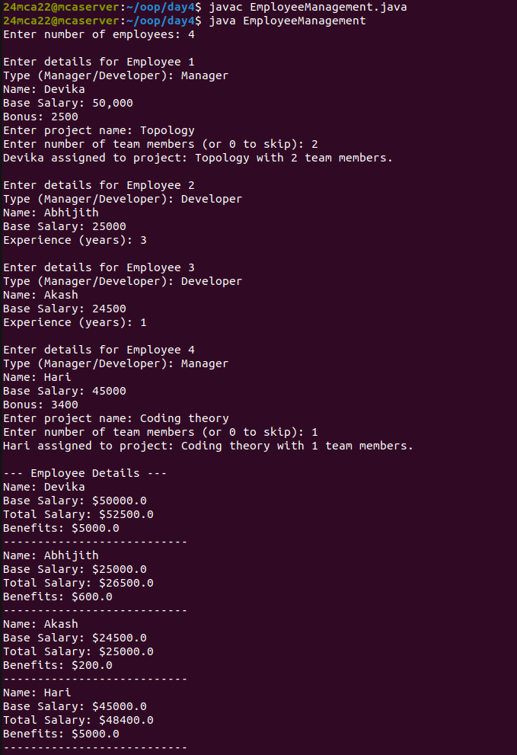

Experiment 14

Graphics Package for Geometric
Figures

Aim:

Create a Graphics package that contains classes and interfaces for geometric figures such
as ‘Rectangle‘, ‘Triangle‘, ‘Square‘, and ‘Circle‘. Test the package by finding the area of
these figures.

Source code:

Main.java

import graphics.*;
import java.util.Scanner;

public class Main {
public static void main(String[] args) {
Scanner scanner = new Scanner(System.in);

// Rectangle
System.out.print("Enter length and width of the rectangle: ");
double length = scanner.nextDouble();
double width = scanner.nextDouble();
Shape rectangle = new Rectangle(length, width);
System.out.println("Area of Rectangle: " + rectangle.area());

// Square
System.out.print("\nEnter side length of the square: ");
double side = scanner.nextDouble();
Shape square = new Square(side);
System.out.println("Area of Square: " + square.area());

// Triangle
System.out.print("\nEnter base and height of the triangle: ");
double base = scanner.nextDouble();
double height = scanner.nextDouble();
Shape triangle = new Triangle(base, height);
System.out.println("Area of Triangle: " + triangle.area());

// Circle
System.out.print("\nEnter radius of the circle: ");
double radius = scanner.nextDouble();
Shape circle = new Circle(radius);
System.out.println("Area of Circle: " + circle.area());

scanner.close();
}
}

Graphics

Circle.java

package graphics;

// Circle class implementing Shape interface
public class Circle implements Shape {
double radius;
final double PI = 3.14159;

public Circle(double radius) {
this.radius = radius;
}

@Override
public double area() {
return PI * radius * radius;
}
}

Rectangle.java

package graphics;

// Rectangle class implementing Shape interface
public class Rectangle implements Shape {
double length, width;

public Rectangle(double length, double width) {
this.length = length;
this.width = width;
}

@Override
public double area() {
return length * width;
}
}

Shape.java

package graphics;

// Interface defining a shape
public interface Shape {
double area();
}

Square.java

package graphics;

// Square class implementing Shape interface
public class Square implements Shape {
double side;

public Square(double side) {
this.side = side;
}

@Override
public double area() {
return side * side;
}
}

Triangle.java

package graphics;

// Triangle class implementing Shape interface
public class Triangle implements Shape {
double base, height;

public Triangle(double base, double height) {
this.base = base;
this.height = height;
}

@Override
public double area() {
return 0.5 * base * height;
}
}

